**Assignment No.: 3**

**Problem Statement:**

Design a library management system with the following databases :

Book(book_id, book_name, title, author, subject, availability, price)

Borrower(brwr_id, brwr_name, city, phone)

Borrows(book_id, brwr_id, do_issue, do_return)

Create the above relations through SQL commands specifying the integrity constraints. Insert at least six tuples in each table such that the following queries yield some results :

1. Find all books which have not been borrowed in February 2015
2. Find the total number of times, the costliest book on ‘Computer Science’ has been borrowed.
3. Find all borrowers living in ‘Kolkata’ who have borrowed at least one book on ‘Mathematics’.

Create an user interface for the above application. Perform the following in your interface design :

1. Input, view, modify and delete ‘Book’ and ‘Borrows’ table in separate forms.
2. Design a form for issuing books. Use combo boxes to accept ‘book_id’ and ‘brwr_id’, include routines to ensure that a borrower can buy books only when it is available.
3. Design a form for returning of books. Change availability of books when a book is issued or returned.
4. In the ‘Return’ form, put a command button with caption ‘Calculate fine’, on clicking which, the fine is displayed in a message box. Fine is charges according to the following rule :

A book must be returned within 14 days from the date of issue. Henceforth, Rs. 1.5/day is charged.

**SQL Operations:**

**Table Book**

**Creation:**

SQL> create table book (

2 book_id varchar2(5) primary key,

3 book_name varchar2(50),

4 title varchar2(50),

5 author varchar2(50),

6 subject varchar2(50),

7 availability number,

8 price number

9 );

Table created.

**Description:**

SQL> desc book;

Name Null? Type

----------------------------------------- -------- ----------------------------

BOOK_ID NOT NULL VARCHAR2(5)

BOOK_NAME VARCHAR2(50)

TITLE VARCHAR2(50)

AUTHOR VARCHAR2(50)

SUBJECT VARCHAR2(50)

AVAILABILITY NUMBER

PRICE NUMBER

**Insertion:**

SQL> insert into book values ('bk1', 'Fundamentals of Data Structure', 'Data Structure', 'Debasis

Samanta', 'Computer Science', 5, 200);

1 row created.

SQL> insert into book values ('bk2', 'Fundamentals of Operating System', 'Operating System', 'Peter

Galvin', 'Computer Science', 5, 400);

1 row created.

SQL> insert into book values ('bk3', 'Linear Programming Problems', 'LPP', 'Narendra Singh',

'Mathematics', 5, 100);

1 row created.

SQL> insert into book values ('bk4', 'Let Us C', 'C Language', 'Yashawant Kanetkar', 'Compu

ter Science', 3, 200);

1 row created.

SQL> insert into book values ('bk5', 'System Programming', 'System Software', 'John J. Donovan'

, 'Computer Science', 2, 150);

1 row created.

SQL> insert into book values ('bk6', 'Modern Algebra', 'Higher Algebra', 'Pallab Mukherjee',

'Mathematics', 2, 300);

1 row created.

**Table Borrower**

**Creation:**

SQL> create table borrower (

2 brwr_id varchar2(5) primary key,

3 brwr_name varchar2(50),

4 city varchar2(50),

5 phone number(10)

6 );

Table created.

**Description:**

SQL> desc borrower;

Name Null? Type

----------------------------------------- -------- ----------------------------

BRWR_ID NOT NULL VARCHAR2(5)

BRWR_NAME VARCHAR2(50)

CITY VARCHAR2(50)

PHONE NUMBER(10)

**Insertion:**

SQL> insert into borrower values ('br1', 'John', 'Kolkata', 5738573713);

1 row created.

SQL> insert into borrower values ('br2', 'Scully', 'Delhi', 9837263647);

1 row created.

SQL> insert into borrower values ('br3', 'Neil', 'Mumbai', 8472727174);

1 row created.

SQL> insert into borrower values ('br4', 'Patrick', 'Kolkata', 6472636472);

1 row created.

SQL> insert into borrower values ('br5', 'Amanda', 'Kolkata', 9572535163);

1 row created.

SQL> insert into borrower values ('br6', 'Roger', 'Bangalore', 8473623642);

1 row created.

**Table Borrows**

**Creation:**

SQL> create table borrows (

2 book_id varchar2(5) references book on delete cascade,

3 brwr_id varchar2(5) references borrower on delete cascade,

4 do_issue date,

5 do_return date,

6 primary key (book_id, brwr_id)

7 );

Table created.

SQL> desc borrows;

Name Null? Type

----------------------------------------- -------- ----------------------------

BOOK_ID NOT NULL VARCHAR2(5)

BRWR_ID NOT NULL VARCHAR2(5)

DO_ISSUE DATE

DO_RETURN DATE

**Insertion:**

SQL> insert into borrows values ('bk1', 'br1', '09-feb-2015', '19-feb-2015');

1 row created.

SQL> insert into borrows values ('bk5', 'br2', '10-feb-2015', '11-feb-2015');

1 row created.

SQL> insert into borrows values ('bk2', 'br6', '11-feb-2015', '22-feb-2015');

1 row created.

SQL> insert into borrows values ('bk2', 'br3', '11-feb-2015', '22-feb-2015');

1 row created.

SQL> insert into borrows values ('bk3', 'br4', '15-feb-2015', '26-feb-2015');

1 row created.

SQL> insert into borrows values ('bk3', 'br5', '15-feb-2015', '26-feb-2015');

1 row created.

SQL> insert into borrows values ('bk4', 'br2', '10-mar-2015', '22-mar-2015');

1 row created.

SQL> insert into borrows values ('bk6', 'br2', '15-mar-2015', '26-mar-2015');

1 row created.

SQL> insert into borrows values ('bk6', 'br5', '15-mar-2015', '26-mar-2015');

1 row created.

SQL> select * from borrows;

BOOK_ BRWR_ DO_ISSUE DO_RETURN

----- ----- --------- ---------

bk1 br1 09-FEB-15 19-FEB-15

bk5 br2 10-FEB-15 11-FEB-15

bk2 br6 11-FEB-15 22-FEB-15

bk2 br3 11-FEB-15 22-FEB-15

bk3 br4 15-FEB-15 26-FEB-15

bk3 br5 15-FEB-15 26-FEB-15

bk4 br2 10-MAR-15 22-MAR-15

bk6 br2 15-MAR-15 26-MAR-15

bk6 br5 15-MAR-15 26-MAR-15

9 rows selected.

**Visual Basic Operations:**

**Table Book forms**

**Insertion:**

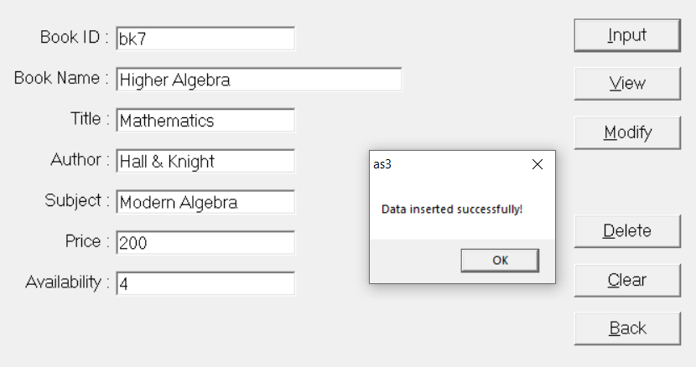

**View:**

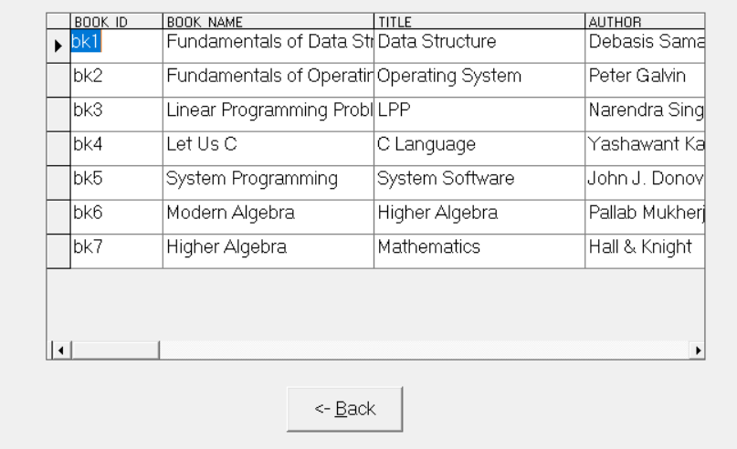

**Modification:**

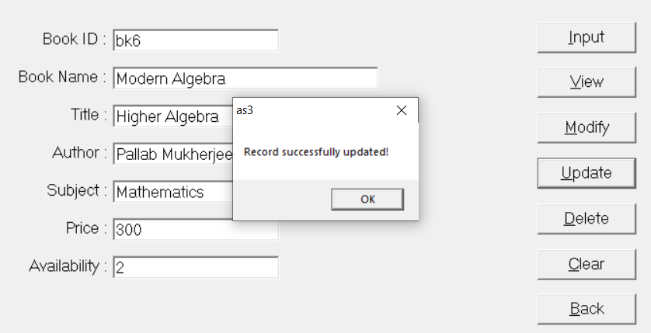

**Deletion:**

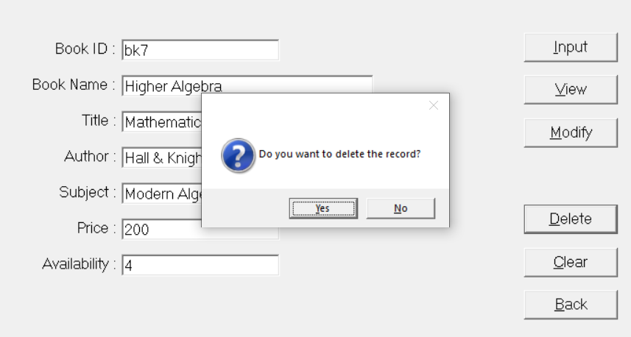

**Book form code**

**Variable Declaration:**

Dim cn As ADODB.Connection, cmd As ADODB.Command

Dim s As String

Dim rs As ADODB.Recordset

**Back Button:**

Private Sub btn_back_Click()

Unload Me

Form5.Show

End Sub

**Clear Button:**

Private Sub btn_clear_Click()

tb_author.Text = ""

tb_availability.Text = ""

tb_bid.Text = ""

tb_bname.Text = ""

tb_price.Text = ""

tb_subject.Text = ""

tb_title.Text = ""

End Sub

**Delete Button:**

Private Sub btn_delete_Click()

Dim id As String

id = InputBox("Enter book ID to delete : ")

rs.MoveFirst

rs.Find "book_id like '" & id & "'"

If (rs.EOF = True) Then

MsgBox "No such record found!"

Else

tb_author = rs("author")

tb_availability = CStr(rs("availability"))

tb_bid = id

tb_bname = rs("book_name")

tb_price = CStr(rs("price"))

tb_subject = rs("subject")

tb_title = rs("title")

If MsgBox("Do you want to delete the record?", vbQuestion + vbYesNo, App.ProductName) = vbYes Then

rs.Delete adAffectCurrent

End If

End If

btn_clear_Click

End Sub

**Input Button:**

Private Sub btn_input_Click()

rs.MoveFirst

If isValid = False Then

tb_bid.SetFocus

Else

If tb_price.Text = "" Then

tb_price.Text = 0

End If

If tb_availability.Text = "" Then

tb_availability.Text = 0

End If

s = "insert into book values ('" + tb_bid.Text + "', '" + tb_bname.Text + "', '" + tb_title.Text + "', '" + tb_author.Text + "', '" + tb_subject.Text + "', " + tb_availability.Text + ", " + tb_price.Text + ")"

cmd.ActiveConnection = cn

cmd.CommandText = s

cmd.Execute

MsgBox "Data inserted successfully!"

End If

End Sub

**Modify Button:**

Private Sub btn_modify_Click()

Dim id As String

id = InputBox("Insert book ID : ")

rs.MoveFirst

rs.Find "book_id like '" & id & "'"

If rs.EOF = True Then

MsgBox "No such record found!"

Else

tb_author.Text = rs("author")

tb_availability.Text = CStr(rs("availability"))

tb_bid.Text = id

tb_bname.Text = rs("book_name")

tb_price.Text = CStr(rs("price"))

tb_subject.Text = rs("subject")

tb_title.Text = rs("title")

btn_update.Visible = True

End If

End Sub

**Update Button:**

Private Sub btn_update_Click()

rs("author") = tb_author.Text

rs("availability") = Val(tb_availability.Text)

rs("book_id") = tb_bid.Text

rs("book_name") = tb_bname.Text

rs("price") = Val(tb_price.Text)

rs("subject") = tb_subject.Text

rs("title") = tb_title.Text

rs.Update

MsgBox "Record successfully updated!"

btn_update.Visible = False

End Sub

**View Button:**

Private Sub btn_view_Click()

Unload Me

Form2.Show

End Sub

**For connecting to the database on load:**

Private Sub Form_Load()

Set cn = New ADODB.Connection

Set cmd = New ADODB.Command

Set rs = New ADODB.Recordset

cn.Open "PROVIDER=OraOLEDB.Oracle;User ID=system;Persist Security Info=False", "system", "system"

rs.Open "select * from book", cn, adOpenDynamic, adLockOptimistic

End Sub

**Checking whether the given book ID is valid:**

Private Function isValid() As Boolean

If (Len(tb_bid.Text)) = 0 Then

MsgBox ("Book ID cannot be blank!")

isValid = False

tb_bid.SetFocus

Else

isValid = True

End If

End Function

**Table Borrower forms**

**Insertion:**



**View :**



**Modification:**



**Deletion :**



**Borrower form code**

**Variable Declaration:**

Dim cn As ADODB.Connection, cmd As ADODB.Command

Dim s As String

Dim rs As ADODB.Recordset

**Back Button:**

Private Sub btn_back_Click()

Unload Me

Form5.Show

End Sub

**Clear Button:**

Private Sub btn_clear_Click()

tb_bid.Text = ""

tb_bname.Text = ""

tb_city.Text = ""

tb_phone.Text = ""

End Sub

**Delete Button:**

Private Sub btn_delete_Click()

Dim id As String

id = InputBox("Enter borrower ID to delete : ")

rs.MoveFirst

rs.Find "brwr_id like '" & id & "'"

If (rs.EOF = True) Then

MsgBox "No such record found!"

Else

tb_phone.Text = CStr(rs("phone"))

tb_bid.Text = id

tb_bname.Text = rs("brwr_name")

tb_city.Text = rs("city")

If MsgBox("Do you want to delete the record?", vbQuestion + vbYesNo, App.ProductName) = vbYes Then

rs.Delete adAffectCurrent

MsgBox "Record deleted successfully!"

End If

End If

btn_clear_Click

End Sub

**Input Button:**

Private Sub btn_input_Click()

rs.MoveFirst

If isValid = False Then

tb_bid.SetFocus

Else

If tb_phone.Text = "" Then

tb_phone.Text = 0

End If

s = "insert into borrower values ('" + tb_bid.Text + "', '" + tb_bname.Text + "', '" + tb_city.Text + "', " + tb_phone.Text + ")"

cmd.ActiveConnection = cn

cmd.CommandText = s

cmd.Execute

rs.Resync

MsgBox "Data inserted successfully!"

End If

End Sub

**Modify Button:**

Private Sub btn_modify_Click()

Dim id As String

id = InputBox("Insert borrower ID : ")

rs.MoveFirst

rs.Find "brwr_id like '" & id & "'"

If rs.EOF = True Then

MsgBox "No such record found!"

btn_update.Visible = False

Else

tb_phone.Text = CStr(rs("phone"))

tb_bid.Text = id

tb_city.Text = rs("city")

tb_bname = rs("brwr_name")

btn_update.Visible = True

End If

End Sub

**Update Button:**

Private Sub btn_update_Click()

rs("brwr_id") = tb_bid.Text

rs("brwr_name") = tb_bname.Text

rs("phone") = Val(tb_phone.Text)

rs("city") = tb_city.Text

rs.Update

MsgBox "Record successfully updated!"

btn_update.Visible = False

End Sub

**View Button:**

Private Sub btn_view_Click()

Unload Me

Form4.Show

End Sub

**For connection to the database of load:**

Private Sub Form_Load()

Set cn = New ADODB.Connection

Set cmd = New ADODB.Command

Set rs = New ADODB.Recordset

cn.Open "PROVIDER=OraOLEDB.Oracle;User ID=system;Persist Security Info=False", "system", "system"

rs.Open "select * from borrower", cn, adOpenDynamic, adLockOptimistic

End Sub

**Checking whether given book ID is valid:**

Private Function isValid() As Boolean

If (Len(tb_bid.Text)) = 0 Then

MsgBox ("Book ID cannot be blank!")

isValid = False

tb_bid.SetFocus

Else

isValid = True

End If

End Function

**Checking whether a phone number is valid:**

Private Sub tb_phone_KeyPress(KeyAscii As Integer)

If (KeyAscii >= Asc("0") And KeyAscii <= Asc("9")) Or KeyAscii = 8 Then

KeyAscii = KeyAscii

Else

MsgBox "Phone number can only contain digits!"

KeyAscii = 0

End If

End Sub

**Table Borrows forms**

**Use of combo box to accept book ID:**

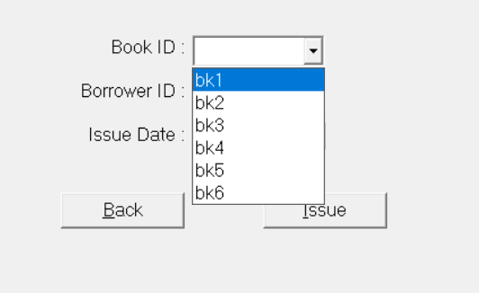

**Use of combo box to accept borrower ID:**

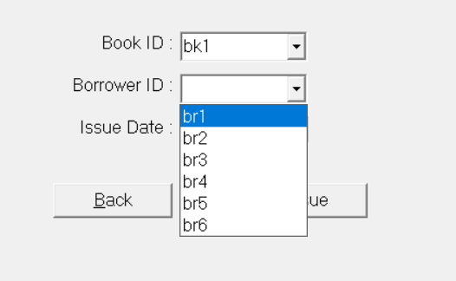

**Issuing of books:**

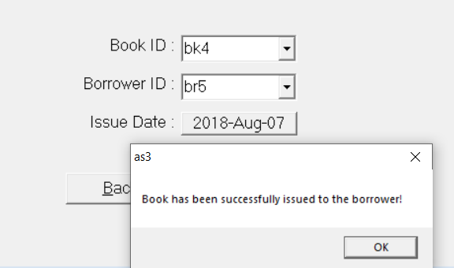

**Changing of availability:**

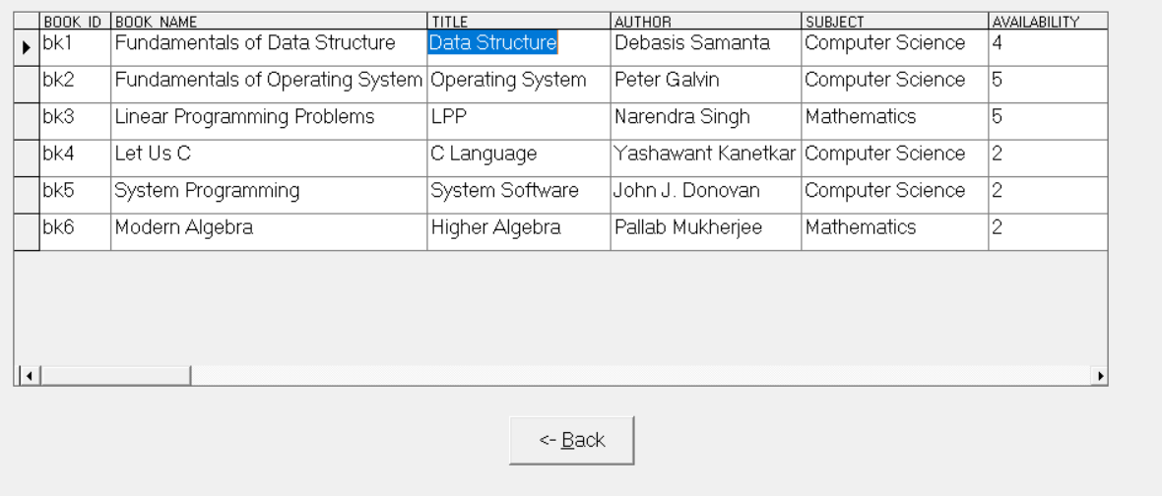

**Issue form code**

**Variable Declaration:**

Dim cn As ADODB.Connection, cmd As ADODB.Command

Dim s As String

Dim rs1, rs2 As ADODB.Recordset

**Back Button:**

Private Sub btn_back_Click()

Unload Me

Form5.Show

End Sub

**Date Button:**

Private Sub btn_date_Click()

Calendar1.Visible = True

btn_date.Visible = False

btn_issue.Visible = False

End Sub

**Issue Button:**

Private Sub btn_issue_Click()

Dim id1 As String

id1 = Format(Calendar1.Value, "YYYY-MM-DD")

s = "insert into borrows values ('" + cmb_book_id.Text + "', '" + cmb_brwr_id.Text + "', '" + id1 + "', NULL)"

cmd.ActiveConnection = cn

cmd.CommandText = s

cmd.Execute

Set rs1 = cn.Execute("update book set availability = availability - 1 where book_id like '" + cmb_book_id.Text + "'")

MsgBox "Book has been successfully issued to the borrower!"

cmb_book_id.Text = ""

cmb_brwr_id.Text = ""

End Sub

**Calendar control:**

Private Sub Calendar1_Click()

btn_date.Caption = Format(Calendar1.Value, "YYYY-MMM-DD")

btn_date.Visible = True

Calendar1.Visible = False

btn_issue.Visible = True

End Sub

**Connecting to database on load:**

Private Sub Form_Load()

Set cn = New ADODB.Connection

Set cmd = New ADODB.Command

Set rs1 = New ADODB.Recordset

Set rs2 = New ADODB.Recordset

cn.Open "PROVIDER=OraOLEDB.Oracle;User ID=scott;Persist Security Info=False", "scott", "tiger"

rs1.Open "select * from book", cn, adOpenDynamic, adLockOptimistic

rs2.Open "select * from borrows", cn, adOpenDynamic, adLockOptimistic

Set rs1 = cn.Execute("select * from book where availability > 1")

Do While (rs1.EOF = False)

cmb_book_id.AddItem rs1("book_id")

rs1.MoveNext

Loop

cmb_book_id.Text = ""

Set rs2 = cn.Execute("select * from borrower")

Do While (rs2.EOF = False)

cmb_brwr_id.AddItem rs2("brwr_id")

rs2.MoveNext

Loop

cmb_brwr_id.Text = ""

btn_date.Caption = Format(Calendar1.Value, "DD-MMM-YY")

End Sub

**Table Borrowers forms**

**Dialog to input book ID:**

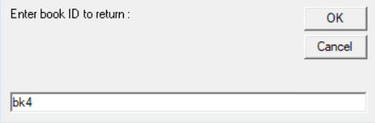

**Dialog to input borrower ID:**

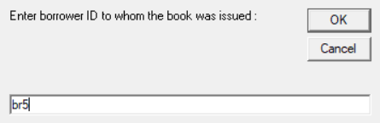

**Dialog when invalid borrower ID / book ID is entered:**

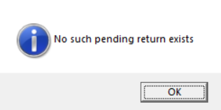

**Returning a book:**

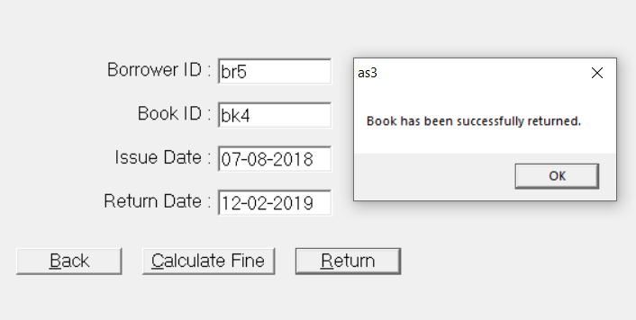

**Calculating the fine:**

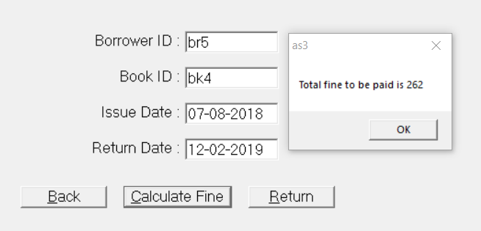

**Return form code**

**Declaration of variables:**

Dim cn As ADODB.Connection, cmd As ADODB.Command

Dim s, id1, id2 As String

Dim rs1 As ADODB.Recordset, rs2 As ADODB.Recordset

**Back Button:**

Private Sub btn_back_Click()

Unload Me

Form5.Show

End Sub

**Calculate fine Button:**

Private Sub btn_cal_fine_Click()

Dim d As Long

Dim fine As Double

d = DateDiff("d", tb_issue_date.Text, tb_return_date.Text)

If d > 14 Then

d = d - 14

fine = d * 1.5

MsgBox "Fine to be paid Rs. " + CStr(fine)

Else

MsgBox "No due fine to be paid!"

End If

End Sub

**Return Button:**

Private Sub btn_ret_Click()

rs2("do_return") = CDate(tb_return_date.Text)

rs2.Update

rs1.Find "book_id like '" + tb_book_id.Text + "'"

rs1("availability") = rs1("availability") + 1

rs1.Update

MsgBox "Book has been successfully returned!"

btn_ret.Visible = False

btn_cal_fine.Visible = False

End Sub

**Connecting to the database on load:**

Private Sub Form_Load()

id1 = InputBox("Enter book ID to return : ")

id2 = InputBox("Enter borrower ID to whom the book was issued : ")

Set cn = New ADODB.Connection

Set cmd = New ADODB.Command

Set rs1 = New ADODB.Recordset

Set rs2 = New ADODB.Recordset

rs2.CursorLocation = adUseClient

cn.Open "PROVIDER=OraOLEDB.Oracle;User ID=scott;Persist Security Info=False", "scott", "tiger"

' rs2.Open "select * from borrows", cn, adOpenDynamic, adLockOptimistic

' rs2.MoveFirst

s = "select brwr_id, book_id, to_char(do_issue, 'DD-Mon-YYYY') as tcd, do_return from borrows where brwr_id like '" & id2 & "' and book_id like '" & id1 & "' and do_return is null"

' MsgBox s

' Set rs2 = cn.Execute(s)

' MsgBox rs2.RecordCount

' s = "brwr_id like '" & id2 & "' and book_id like '" & id1 & "' and do_return is null"

'MsgBox s

rs2.Open s, cn, adOpenDynamic, adLockOptimistic

If (rs2.RecordCount = 0 Or rs2.RecordCount = -1) Then

MsgBox "No such pending return exists!", vbInformation

btn_ret.Visible = False

btn_cal_fine.Visible = False

Else

'rs2.MoveFirst

'MsgBox rs2("do_issue")

tb_issue_date.Text = rs2.Fields("tcd")

tb_return_date.Text = Format(Date, "DD-mmm-YYYY")

rs1.Open "select * from book", cn, adOpenDynamic, adLockOptimistic

End If

tb_book_id.Text = id1

tb_brwr_id.Text = id2

End Sub

**Menu form**

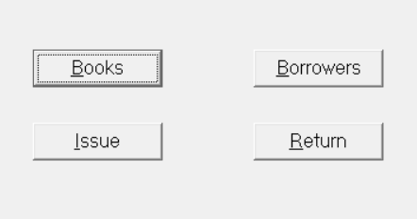

**Menu form code**

**Books Button :**

Private Sub Command1_Click()

Unload Me

Form1.Show

End Sub

**Borrowers Button :**

Private Sub Command2_Click()

Unload Me

Form3.Show

End Sub

**Issue Button :**

Private Sub Command3_Click()

Unload Me

Form6.Show

End Sub

**Return Button :**

Private Sub Command4_Click()

Unload Me

Form7.Show

End Sub

**SQL Queries**

1. **Find all books which have not been borrowed in February 2015**

SQL> select b.book_id, b.title from book b where b.book_id in (

2 select book_id from borrows where do_issue < '01-feb-2015' or do_issue > '28-feb-2015' );

BOOK_ TITLE

----- --------------------------------------------------

bk4 C Language

bk6 Higher Algebra

1. **Find total number of times the costliest book on “Computer Science” have been borrowed**

SQL> select count(book_id) from borrows where book_id in (

2 select book_id from book where price in (

3 select max(price) from book

4 )

5 );

COUNT(BOOK_ID)

--------------

2

1. **Find all borrowers living in ‘Kolkata’ who have borrowed at least one book in ‘Mathematics’**

SQL> select brwr_name from borrower where city = 'Kolkata' and brwr_id in (

2 select brwr_id from borrows where book_id in (

3 select book_id from book where subject = 'Mathematics'

4 )

5 );

BRWR_NAME

--------------------------------------------------

Patrick

Amanda